**Project plan**

1. **Introduction**
2. **Background**
3. **Requirements**
4. **Goals**
5. **Schedule**
6. **Groups**
7. **System design**
8. **Involving device/Technique**

**1 Brief introduction**

Vital signs reflect the health level of human body. The abnormal appearance of vital signs is considered a symptom of disease, moreover, it can also be used to predict the occurrence of some chronic disease. General vital sign of human body including heart rate, brain wave, weight (also known as body fat rate, BFT) and the quality of blood, for example blood pressure. For certain groups of people, additional data is requisite as well, for instance, sleep quality for pregnancy and the old, and blood sugar for people who has diabetes. Most of these data might not be of much concern of public attention, however, it is this lack of attention which is the cause of illness. The main goal of the system is to receive the monitored data and analyzes them with corresponding algorithm, to generating a report for users and giving some suggestion based on their health status.

* 1. **Background**

The importance of a monitoring system for vital signs is increasing year by year. According to the statistics from WTO, cardiovascular disease (CVDs) is the most fatal of death worldwide, every year the rate of death is always at the top among all disease. Statistics show that in the year 2016, it is estimated that about 17.9 million of patients died from CVDs, which accounts for 31% of all global deaths. Among these deaths, 85% of them are due to heart attack and stroke [1]. Diabetes mellitus (DM) is considered as a global epidemic, which makes a great influence on global population. Due to an approximately estimation, 6%-8% of world’s population is suffer from DM. Compared to the number of 336 million affected people in 2011, it predicts that in 2030, the increase will be 50.8% and nearly 552 million people will involve in DM [2]. The increasing incidence of disease is a trend in modern society; therefore, early diagnosis is becoming more and more significant. With a health monitoring system, early symptom is more likely be perceived and treatment can be carried out earlier to reduce the mortality. Positive findings from U.K. Department of Health study showed that with the assistant of mobile health monitoring technology, mortality of CVDs and DM patients has decreased by up to 45%.[3]

* 1. **Motivation**

We propose to develop and implement a system for monitoring human health based on measured data. There are already many different detection systems on the market, such as Apple, Xiaomi, and Huawei. In general, these systems have basic functions which are same as our expected system such as heart rate, temperature and so on. However, there are still some deficiency exist in these systems. For example, the Xiaomi system is inadequate in monitoring heart rate, users cannot view tracks by period. For Huawei system, its data reception is unstable which may lead to the imprecision of receiving data. Apple does better in previous aspect, it also provides medical advice for users, however, high expense is also as a serious problem. In our system, there is a useful function that most of system does have. The system should output the average value according to the user’s level. (user level calculated based on user’s age, height, and weight) Our system should also integrate the statistics of multiple sensors, then give user a succinct suggestion, such as how much exercise to get, recommend foods or what behaviors to avoid.

1. **User Requirements**

This mobile system is designed for the pregnant women to monitor their vital signs and help them keep healthy during the pregnancy. To be easy to use for most of the pregnant women, the application should be easy enough to operate and understand.

* **Kernel Requirement**
  1. **Make Connection:** Users could use this application to connect the wearable device (given types)
  2. **Bodyweight management:** Users would receive a caution every day to record the bodyweight and can type the body weight number manually.
  3. **Report receive：**
     1. Users can view kinds of data in the last cycle.
     2. Users can view the visualized data diagrams.
     3. Users can be given guidance of life and health.
     4. User can see the long-term data for a period.
* **Additional Requirement**
  1. Users can open the application directly without log in. (Easy to start using)
  2. Users can click the bottom menu to select module.
  3. Users can store their reports for further use.
  4. Users can get help by application about operations.
  5. Users can enter the personal body information for more accurate forecast.

**Functional Requirement**

* **Data Capture module**
  1. The mobile system (Android Application) can connect with the wearable devices which include heart rate belts, brain ware, smart scale, temperature sensor, breathing rate sensor, blood pressure sensor.
  2. The vital signs will be measuring every minute. The vital data will be sent from wearable device to mobile application every 30 minutes.
  3. The bodyweight data is captured by manual record.
  4. The year and height are recorded from users.
  5. The data will be sent to the integration module for the next step.
  6. The connection between device and system is blue tooth.
* **Data integration module**
  1. The data will be updated every 30 minutes when the system collects data from wearable device.
  2. The data will be processed and temporarily store in the application's memory.
  3. Multiply types of data can be integration in the mobile system.
  4. The received data will be stored for a month in the application memory for users' views.
  5. The data will be split into different categories and shown to the users.
  6. The data will be sent to the analysis module for the next step.
* **Data report and analysis module**
  1. Application could send a piece of message (every-day report) about the vital status analysis and advices at 8 a.m.
  2. The report is about his/her body vital data. The report will include every-day vital signs data after processing and will give some advices according to the analysis algorithm such as having more sleep or having abnormal status and need to see doctor.
  3. The system could generate the report by the suggestion data and analysis algorithm daily and monthly (weekly).
  4. The report could be preserved by users and exported.
* **Data storage module**
  1. The data from users should be stored both in PC and mobile system.
  2. Considering the limited memory, the details of past data will be cleaned up and the daily report will be stored in the mobile system.
  3. The user could connect with the PC monthly and send the data for the long-term storage.
* **Task management module (interface)**
  1. The system will push the every-day reports, suggestions, and analysis at 8 a.m.
  2. The system will send a message to user if user does not. wear the devices.
  3. The data capture function can be switch on/off.
  4. The system will send a message if the user does not record the body weight until 8 p.m. every day.
  5. The user can view three mode of application:
     + current/last measured data
     + today's report
     + Long term report
     + Settings

1. **Goals**

The final goal of the project is to develop a monitoring system to receive data from devices.

1. **Requirements Specification**

Initially, the discussion was done in group to speculate users’ requirements. By attending the workshop with other group of the same project, information from testee was collected and parameters of devices are received. Finally, meeting with supervisor helps to modify requirement and affirm the goals of the subsequent project.

1. **Interim report**

Done by the half-stage of the project. The report should include 3 main parts. Firstly, the **current stage of project** should be mentioned, including **updated and expanded description of problem**, **background information** about the research, **requirement specification** for project, **initial design** (about system, prototype, and implementation) and **key implementation decisions**. The second part is about future, which includes discussion about problem encountered and time plan for the project. The last part is details, covering project name, group members and supervisor and so on.

1. System Design

The system is designed into 5 modules, which can implement respective functions. The details about each module are shown below.

1. Prototype
2. Final System Implementation
3. **Schedule**

The process of project is briefly shown below:

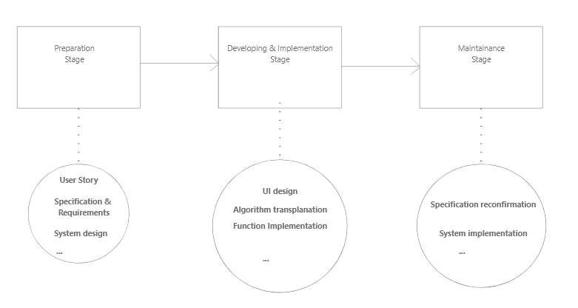

The Gantt graph of the whole project is shown below:

1. **Groups (Member Assignment)**

**Software UI:** Rongjiang Yang

**Connection: TBD**

**Algorithm transplantation:** Hudie Liu, Xiaotian Xia

**Function menu:** Yiyang Li, Haonan Chen

1. **System design**

**Overview**

The whole system is a mobile system designed for monitoring pregnant women’s vital signs. The application is on android platform and can connect to several wearable devices for data capture. The user operations should be easy and direct enough. The system will include five main modules to develop, which respectively is data capture module, data integration module, report and analysis module, data storage module, and task management module. The kernel function is giving a report to the users by the captured data. To achieve this goal, we will use some open source algorithm and existing SDK.

**Data Capture module**

1. The mobile system (Android Application) can connect with the wearable devices which include heart rate belts, brain ware, smart scale, temperature sensor, breathing rate sensor, blood pressure sensor.

2. The vital signs will be measuring every minute. The vital data will be sent from wearable device to mobile application every 30 minutes.

3. The bodyweight data is captured by manual record.

4. The year and height are recorded from users.

5. The data will be sent to the integration module for the next step.

6. The connection between device and system is blue tooth.

**Data integration module**

1. The data will be updated every 30 minutes when the system collects data from wearable device.

2. The data will be processed and temporarily store in the application's memory.

3. Multiply types of data can be integration in the mobile system.

4. The received data will be stored for a month in the application memory for users' views.

5. The data will be split into different categories and shown to the users.

6. The data will be sent to the analysis module for the next step.

**Data report and analysis module**

1. Application could send a piece of message (every-day report) about the vital status analysis and advices at 8 a.m.

2. The report is about his/her body vital data. The report will include ever-day vital signs data after processing and will give some advices according to the analysis algorithm such as having more sleep or having abnormal status and need to see doctor.

3. The system could generate the report by the suggestion data and analysis algorithm daily and monthly (weekly)

4. The report could be persevered by users and exported.

**Data storage module**

1. The data from users should be stored both in PC and mobile system.

2. Considering the limited memory, the details of past data will be cleaned up and the daily report will be stored in the mobile system.

3. The user could connect With the PC monthly and send the data for the long-term storage.

**Task management module (interface)**

1. The system will push the every-day reports, suggestions, and analysis at 8 a.m.

2. The system will send a message to user if user does not wear the devices.

3. The data capture function can be switch on/off.

4. The system will send a message if the user does not record the body weight until 8 p.m. every day.

5. The user can view three mode of application:

Current / last measured data

Today’s report

Long term report

settings

1. **Involving Device/Technique**

**Heart rate device**: Polar H10

**Brain ware device**: NeuroSky TGAM

**Smart scale device**: Yunmai

**Developing tools:** Genymotion simulator, Adobe XD, Android Studio.